SOL
VS. 3  (Current) | 1. In what year did women arrive in Jamestown? | 2. The arrival of women made it possible for settlers to establish __________________________ and a more permanent  __________________________ | 3. What group of people was brought to Jamestown as a source of labor? | 4. What crop in Jamestown was also used as money?
VS. 1  (Review) | 5. 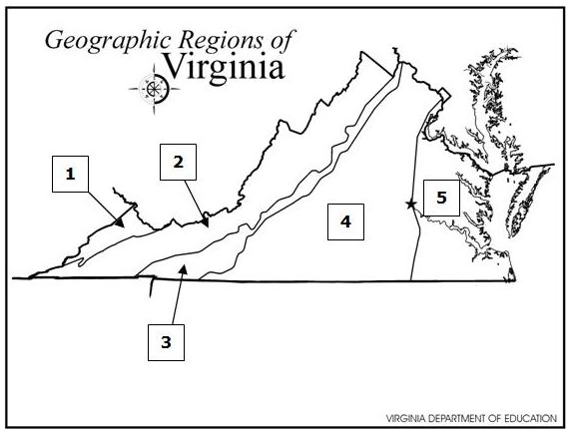  Jeff lives in the Valley and Ridge region. If he wants to visit the Piedmont region, he will have to travel from—  - 2 to 4  - 3 to 5  - 1 to 3  - 1 to 5 | 6. In what year would Jamestown settlers have most likely experienced a forced work program that resulted in their survival?  1607: Jamestown was established  1608: John Smith leader of Jamestown colony  1609: Winter 1609-1610 “Starving Time”  1612: Tobacco farming introduced  1619: First meeting of Virginia Assembly; Africans arrive  1620: Additional English women arrive  _______________________________________ | 7. Which would a tourist likely encounter while visiting the Piedmont Region of Virginia?  - Shenandoah Valley  - Rolling Hills  - Coal Mines in Southwest Virginia  - Lighthouse by Atlantic Ocean | 8. Recreation is a major industry in which region?  - Piedmont  - Appalachian Plateau  - Coastal Plain  - Blue Ridge Mountains
VS.2 a-d  (Review) | 9. If the American Indians from the Powhatan tribe wanted to visit the Cherokee Indians, in which direction would they have traveled?  - North  - South  - East  - West | 10. Which sentence explains a common geographic characteristic of these rivers?  Virginia Rivers  - James  - York  - Potomac  - Rappahannock  a. Each creates an island.  b. Each flows into the Chesapeake Bay.  c. Each flows into the Dismal Swamp  d. Each creates an isthmus. | 11. Alexandria is to the Potomac River as the Jamestown is to the—  - Rappahannock River  - York River  - James River  - Roanoke River | 12. If Madeline traveled north from Richmond, which bordering state would she enter?  - Kentucky  - West Virginia  - Maryland  d. North Carolina
VS. 2-g  (Review) | 13. If an individual chooses to participate in an economic venture, their main goal is to—  - make money  - create jobs  - lose money  - take a risk | 14. How long ago did American Indian people first live in Virginia?  - Hundreds of years ago  - Millions of years ago  - Thousands of years ago  - Ninety years ago | 15. Which language group was located primarily in the Coastal Plain region of Virginia?  - Algonquian  - Siouan  - Iroquoian | 16. “We must provide them with ships and supplies for the journey and settlement.”  Who most likely made this statement?  - Stockholders  - King James I  - Settlers  - Captain John Smith
SOL
VS. 3  (Current) | 1. In what year did women arrive in Jamestown?  1619 | 2. The arrival of women made it possible for settlers to establish FAMILIES and a more permanent SETTLEMENT | 3. What group of people was brought to Jamestown as a source of labor?  AFRICANS | 4. What crop in Jamestown was also used as money?  TOBACCO
VS. 1  (Review) | 5.  Jeff lives in the Valley and Ridge region. If he wants to visit the Piedmont region, he will have to travel from—  a. 2 to 4  b. 3 to 5  c. 1 to 3  d. 1 to 5 | 6. In what year would Jamestown settlers have most likely experienced a forced work program that resulted in their survival?  1607: Jamestown was established  1608: John Smith leader of Jamestown colony  1609: Winter 1609-1610 “Starving Time”  1612: Tobacco farming introduced  1619: First meeting of Virginia Assembly; Africans arrive  1620: Additional English women arrive  _______________________________________ | 7. Which would a tourist likely encounter while visiting the Piedmont Region of Virginia?  - Shenandoah Valley  - Rolling Hills  - Coal Mines in Southwest Virginia  - Lighthouse by Atlantic Ocean | 8. Recreation is a major industry in which region?  - Piedmont  - Appalachian Plateau  - Coastal Plain  - Blue Ridge Mountains
VS.2 a-d  (Review) | 9. If the American Indians from the Powhatan tribe wanted to visit the Cherokee Indians, in which direction would they have traveled?  - North  - South  - East  - West | 10. Which sentence explains a common geographic characteristic of these rivers?  Virginia Rivers  - James  - York  - Potomac  - Rappahannock  a. Each creates an island.  b. Each flows into the Chesapeake Bay.  c. Each flows into the Dismal Swamp  d. Each creates an isthmus. | 11. Alexandria is to the Potomac River as the Jamestown is to the—  - Rappahannock River  - York River  - James River  Roanoke River | 12. If Madeline traveled north from Richmond, which bordering state would she enter?  - Kentucky  - West Virginia  - Maryland  d. North Carolina
VS. 2-g  (Review) | 13. If an individual chooses to participate in an economic venture, their main goal is to—  - make money  - create jobs  - lose money  - take a risk | 14. How long ago did American Indian people first live in Virginia?  - Hundreds of years ago  - Millions of years ago  - Thousands of years ago  - Ninety years ago | 15. Which language group was located primarily in the Coastal Plain region of Virginia?  - Algonquian  - Siouan  - Iroquoian | 16. “We must provide them with ships and supplies for the journey and settlement.”  Who most likely made this statement?  - Stockholders  - King James I  - Settlers  - Captain John Smith

